Close correlation between solar activity and earthquakes

A.M. Eigenson
Ivan Franko Lviv National University (Ukraine)
Bar Ilan University (Israel)

e-mail: aleksey.eigenson@gmail.com

Large earthquakes in the last 260 years are compared with the epochs of minima of Solar activity. Close correlation between earthquakes and the minima of solar cycles is shown. If the current trend continues, the next major earthquakes are predicted to be around 2018 and 2029.

Key words: Solar activity, seismology, earthquakes, prognosis.

Recently, D.Grishchenko (2015) published the data of large earthquakes in the “Fire Circle” and pointed out that intervals between them are 22 years on average. This number is thought-provoking, and my further investigation revealed a very close correlation between the earthquakes and years of the minima of 11-year cycles of solar activity.
We first recall that geophysical responses are not exactly connected with absolute extrema of Solar activity but rather with the epochs of these extrema (Eigenson, 1963). These epochs may continue during some years. We also recall that the 22-year Solar cycle is not simply the sum of two 11-years cycles, but has an important feature. Namely, in a given 11-year cycle the sunspots have one polarity, but in the next cycle this polarity changes the opposite. So we can speak about the influence of the activity of Solar electromagnetic field on earthquakes. Indeed, the lithosphere plates in the viscous magma in the upper mantle have the own magnetic field, and the electromagnetic radiation of the Sun in the minimum of its activity may play the role of a “trigger” provoking the earthquakes.
The comparison of Solar and Earth events is shown in Table 1 in the Appendix where we included the earthquakes of magnitude no less than 7 (the comparison is also illustrated in Fig. 1, see below). The first column is the number of Solar activity cycle, the second shows the year of absolute minimum, followed by the month of minimum in that year, the year of the earthquake, the month of the earthquake, the location of earthquake and finally the magnitude. We use the most complete catalogue of earthquakes in the last 260 years (http://earthquake.usgs.gov) as well as available published data (https://en.wikipedia.org/wiki/Lists_of_earthquakes). Our compilation includes 24 Solar cycles and 352 different earthquakes in total.
The correlation between the years of minima of Solar cycles and years of earthquakes is shown in Fig. 1 below. Figure 1 and the inspection of Table 1 in the Appendix show that earthquakes closely follow the epochs of Solar activity minima (the calculated coefficient of correlation between the years of minima and earthquakes is 0.9998). This is the main conclusion of this article.
We note that the number of earthquakes increases with time. This increase is consistent with the known picture of varying Solar activity over the last century.
It's interesting to compare the number of earthquakes with the values of Wolf numbers W. The comparison is shown in Table 2 for the last 5 cycles. We observe that the maximal number of earthquakes corresponds to minimal value of W. This is further illustrated in Figure 2 where we plot W and the number of earthquakes: minima (maxima) of W approximately correspond to maxima (minima) of the number of earthquakes, the trend particularly visible in the last cycles starting from 1964.
Our result opens a possibility for prognosis of earthquakes because Solar activity can be predicted for many years in the future. For example, if this trend continues, the next major earthquakes will occur around 2018 and 2029. The value of Wolf number forecasted elsewhere is predicted to be 4 in 2018.
We note recent strong earthquakes in Nepal and Chile (2015) and that the next Solar minimum will be in 2018. We can suppose that these earthquakes occur in the epoch of this minimum.
We also note that using our correlation and the existing data on past earthquakes extending into ancient times one could gain insights into the cycles of Solar activity in the past.
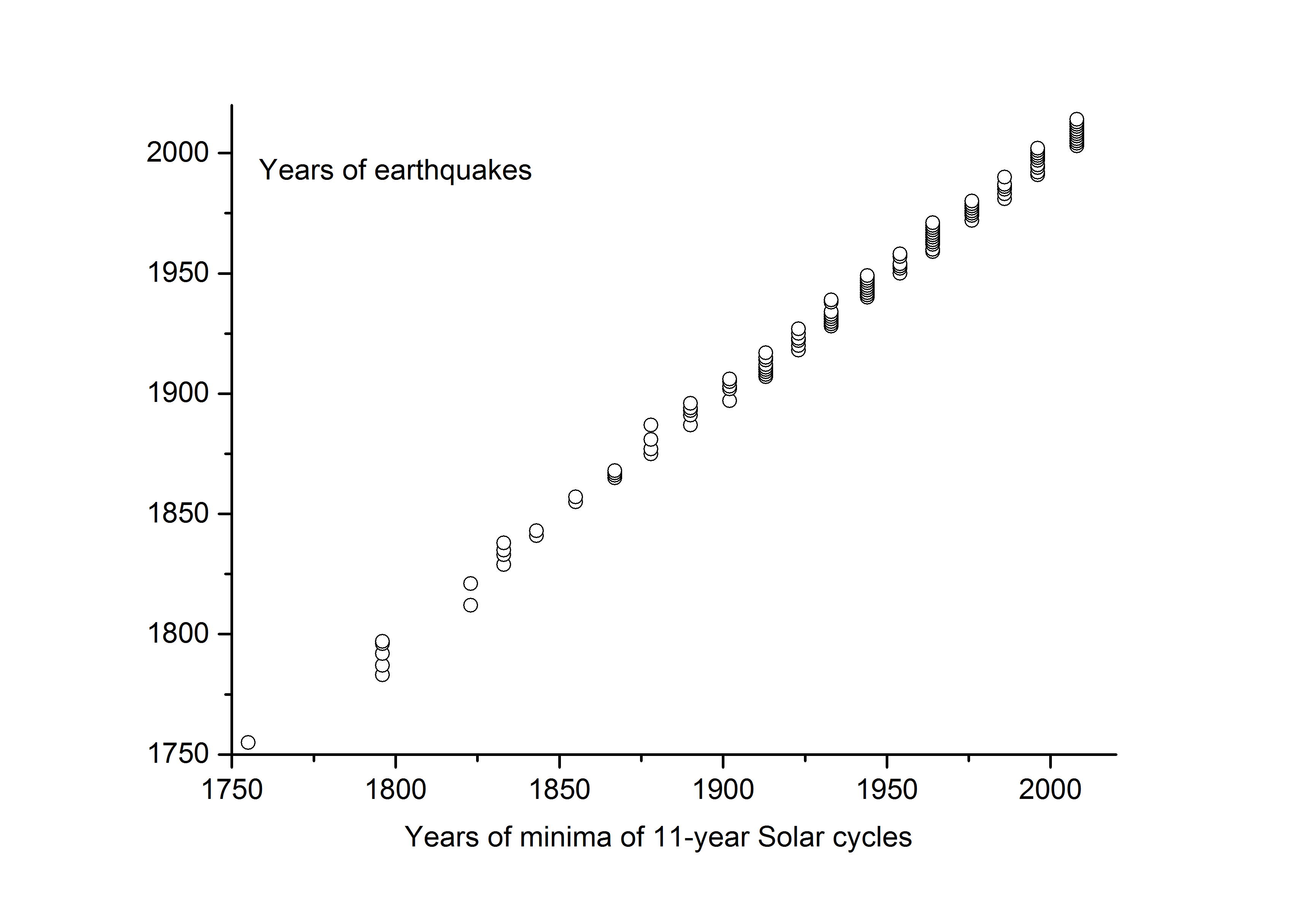
Fig.1. Correlation between the years of minima of Solar 11-year cycles and years of earthquakes.

Table 2.
Cycle Year of min. W min. Number of earthquakes

20 1964 15 30
21 1976 13 20
22 1986 13 8
23 1996 10 40
24 2008 4 114

We recall that the ideas about influence of Solar activity on earthquakes was proposed many years ago by M. S. Eigenson (1948,1963). These ideas have been discussed since (see, e.g., S.Maus et.al. (2001), Thebault et.al. (2010) and Campbell (2009) for discussion and review). In particular, the analysis of Campbell led them to conclude that earthquakes may be accompanied by the solar-terrestrial disturbance field. This is consistent with the close correlation between Solar cycles and earthquakes discussed here. Related discussions can also be found in S-I.Akasofu and S.Chapman (1972) and H.Berg (1957) as well as in the investigations of G.Katterfeld and G.F.Landersgausen (1962) and B.L.Lichkov (1965).
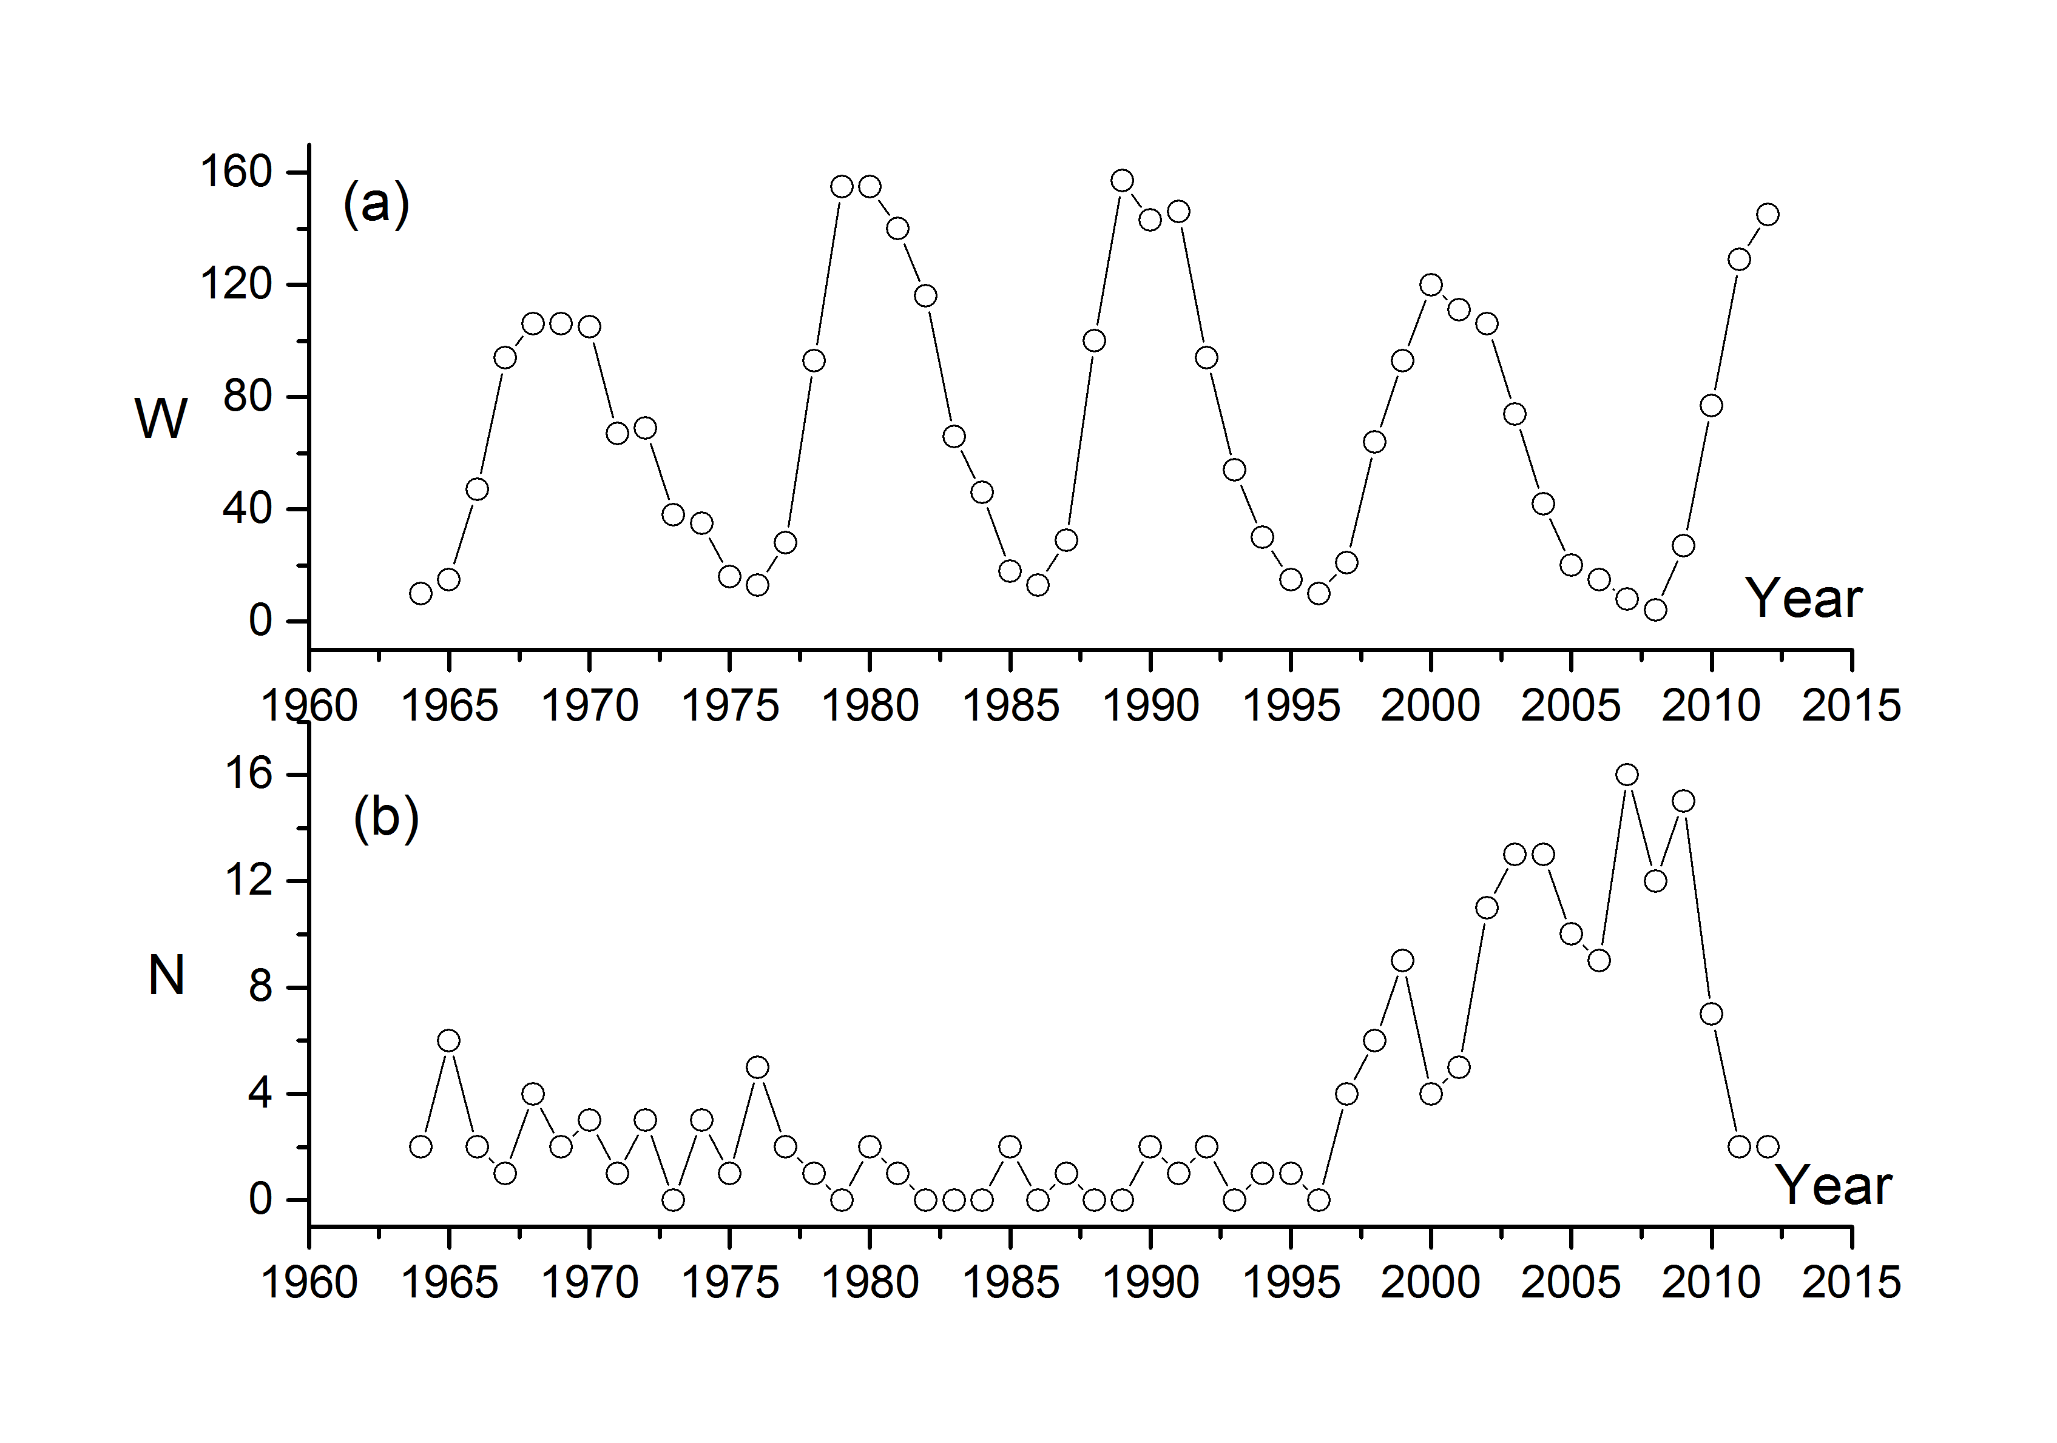
Fig.2 (a) Wolf numbers W and (b) Number of earthquakes N as functions of the year.

We note that from the mathematical point of view, the sequences of events on Sun and Earth can be represented by the time series and can therefore be treated by the corresponding methods (see e.g. Anderson, 1973; Brillindger, 1975; Terebizh, 1992; Vityazev, 2001) including a new approach using pattern recognition theory as discussed recently by the author (Eigenson, 2013).
Noting that seismic and volcanic activities are related, it would be interesting to study the correlation between Solar and volcanic activities. This will be the subject of future work.

In summary, we have found that large earthquakes closely follow the epochs of Solar activity. The correlation coefficient between the years of minima of Solar activity and earthquakes is 0.9998. We have also found that the maximal number of earthquakes corresponds to the minimal value of Wolf numbers. If the current trend continues, the next major earthquakes will occur around 2018.

Acknowledgments
I am grateful to K.A.Trachenko, Kh.Meliksetyan, N.N.Samus, A.V.Kendzera, E.A.Ostrovsky, I.V.Stasyuk, R.E.Gladyshevsky, M.V.Varukh, N.N.Pavlun, V.V.Furman, Yu.V.Lyakhov, V.A.Voloshinovsky, R.E.Rykaluk, Ya.S.Yatskiv, I.V.Popadyuk, L.M.Khazan, G.S.Pavlov for discussions.

References
S-I. Akasofu, S.Chapman. Solar-terrestrial physics. 1972.
T. Anderson. Statistical analyses of time series. 1973.
H.Berg. Solar-Terrestrische Beziehungen in Meteorologie und Biologie. 1957.
D.Brillindger. Time series. Data and theory. 1975.
W.H.Campbell. Journal of Geophysical research 114, AO5307,2009.
R.P.Cane. Solar Physics, 205, 2002.
A.M.Eigenson. Visnyk of Lviv University, ser. Mech-Math, issue 69, 2013.
M.S.Eigenson. Solntse, pogoda i klimat (in Russian). English translation: Sun, whether and climate. 1963.
M.S.Eigenson, M,S.Gnevyshev, A.I. Ol, B.M.Rubashov. Solnechnaya aktivnost i ee zemnye proyavlenia (in Russian). English translation: Solar activity and it's terrestrial manyfestations, 1948.
D.Grishchenko. Vselennaya, prostranstvo, vremya (in Russian). English translation:
Universe, space, time. Kiev, February 2015.
G.Katterfeld, G.F.Landersgausen. Soveshchanie po problemam astrogeologii.
(in Russian). English translation: Conference on astrogeology.1962.
B.L.Lichkov. K osnovam sovremennoy teorii Zemli (in Russian). English translation: On the base of modern theory of Earth. (1965)
S.Maus et.al. Geophys.Res., 29, 2002.
V.Yu.Terebizh. Analiz vremennykh ryadov v astrofizike (in Russian). English translation: Analyse of time series in astrophysics, 1992.
E.Thebault et.al. Space Sci Rev. 22 July, 2010.
V.V.Vityazev, Analiz neravnomernyh vremennyh ryadov (in Russian). English translation: Analysis of irregular time series. 2001.

APPENDIX

Table 1.

Cycle Solar.min. Date Location Magnitude
number of earthquake of earthquake
Year Month

1 1755 XI

1755 06 Iran
1755 11 Portugal 8,7

5 1796 V

1783 02 Italy
1787 05 Puerto Rico 8.0
1792 05 Kamchatka 8.0
1796 05 Moldavia 7.0-8.0
1797 02 Ecuador

7 1823 V

1812 03 Venezuela 7.7
1821 05 Moldavia 7.0-8.0
1821 07 Camana, Peru 8.2
1821 11 Moldavia 7.0

8 1833 XI
1829 11 Moldavia 7.0-8.0
1833 05 India 7.5
1833 09 China 8.0
1833 11 Indonesia 9.2
1835 02 Chile 8.2
1838 01 Moldavia 7.0

9 1843 VII

1841 05 Кamchatka 8.4
1843 02 Leeward Islands 8.3

10 1855 V

1855 01 New Zealand 8.0
1857 01 California 8.0

11 1867 III

1865 04 Moldavia 9.0
1866 11 Moldavia 7.0
1867 06 Kazakhstan 7,3
1868 08 Peru 9.0
12 1878 XII
1875 05 Colombia 7.3
1877 05 Chile 8.3
1881 - California 7.9
1887 05 Mexico 7.4

13 1890 III
1887 06 Kazakhstan 7.3
1891 10 Japan 8.0
1893 08 Moldavia 7.0
1893 09 Moldavia 7.0
1894 03 Moldavia 7.0
1894 07 Turkey 7.0
1894 08 Moldavia 7.0
1894 09 Moldavia 9.0
1896 06 Japan 8,5

14 1902 II
1897 06 India 8.3
1902 04 California 8.2
1902 04 Azerbaigan 6.9
1902 04 Guatemala 7.5
1903 04 Turkey 7.0
1903 05 Turkey 5.8
1903 08 Greece 8.3
1905 04 India 7.5
1905 07 Mongolia 8.4
1905 09 Italy 7.9
1906 01 Ecuador 8.8
1906 08 Chile 8.2

15 1913 VII
1907 04 Mexico 7.7
1907 10 Tajikistan 8.0
1908 12 Peru 8.2
1908 12 Italy 7.2
1909 01 Iran 7.3
1910 04 Taiwan 7.6
1911 01 Kyrgyzstan 7.8
1911 02 Tajikistan 7.4
1911 06 Mexico 7.7
1911 06 Japan 8.1
1912 08 Turkey 7.8
1914 10 Turkey 7.0
1915 01 Italy 7.0
1917 07 China 7.5

16 1923 VIII
1918 02 China 7.3
1918 10 Mona Passage 7.5
1918 12 Canada 7.0
1920 06 Taiwan 8.0
1920 12 China 7.8
1922 11 Chile-Argentina 8.5
1923 02 Kamchatka 8.5
1923 03 China 7.3
1923 09 Japan 7.9
1925 03 China 7.1
1927 03 Japan 7.6
1927 05 China 7.6

17 1933 IX
1928 12 Chile 7.6
1929 05 Iran 7.4
1929 05 Canada 7.0
1929 11 Canada 7.2
1930 05 Iran 7.2
1931 01 Mexico 7.8
1931 02 New Zealand 7.9
1931 08 China 8.0
1932 06 Mexico 8.1
1932 12 China 7.6
1933 03 Japan 8.4
1933 08 China 7.4
1933 11 Canada 7.4
1934 01 India - Nepal 8.1
1934 03 Moldavia 9.0
1938 02 Indonesia 8.5
1939 12 Turkey 7.8

18 1944 II
1940 05 Peru 8.2
1940 11 Romania 7.3
1941 04 Australia 7.2
1942 08 Guatemala 7.9
1942 08 Peru 8.2
1942 11 Turkey 7.6
1942 12 Turkey 7.3
1943 04 Chile 8.2
1943 09 Japan 7.4
1943 11 Turkey 7.6
1944 01 Argentina 7.4
1944 02 Turkey 7.4
1944 12 Japan 8.1
1945 01 Japan 7.1
1945 11 Pakistan 8.0
1946 06 Canada 7.3
1946 08 Dominican Rep 8.0
1946 11 Peru 7.3
1946 12 Japan 8.1
1947 08 Iran 7.3
1947 11 Peru 7.3
1948 05 Peru 7.4
1948 05 China 7.3
1948 06 Japan 7.3
1948 10 Turkmenistan 7.3
1949 07 Tajikistan 7.5
1949 08 Canada 8.1

19 1954 IV
1950 08 Tibet 8.6
1950 04 Kamchatka 8.6
1950 08 Tibet 8.6
1952 03 Japan 8.1
1952 11 Kamchatka 9.0
1953 03 Turkey 7.3
1953 08 Greece 7.1
1953 12 Peru 7.4
1954 03 Spain 7.9
1954 04 Greece 7.1
1957 01 California 7.9
1957 03 Alaska 9.1
1957 04 Turkey 7.1
1957 06 Stanovoy, Russia 7.6
1957 07 Iran 7.1
1957 07 Mexico 7.9
1957 12 Mongolia 8.1
1957 12 Iran 7.1
1958 01 Peru 7.3
1958 11 Kuril Islands 8.3

20 1964 X

1959 04 Taiwan 7.5
1960 01 Peru 7.5
1960 05 Chile 7.9
1960 05 Chile 9.5
1962 05 Mexico 7.0
1962 09 Iran 7.1
1963 10 Kuril Islands 8.5
1964 03 Alaska 9.2
1964 06 Japan 7.5
1964 10 Turkey 7.0
1965 01 Indonesia 7.6
1965 02 Chile 7.0
1965 03 Afghanistan 7.8
1965 03 Chile 7.4
1965 03 Greece 7.1
1965 04 Alaska 8.7
1965 08 Mexico 7.3
1966 03 China 7.0
1966 10 Peru 8.1
1967 07 Turkey 7.3
1968 05 Japan 8.2
1968 05 New Zealand 7.1
1968 08 Mexico 7.1
1968 08 Iran 7.3
1969 02 Morocco 7.8
1969 12 Guadeloupe 7.2
1970 05 Peru 7.9
1970 06 Canada 7.0
1970 07 Colombia 8.0
1971 07 Chile 7.5

21 1976 VI
1972 01 Taiwain 7.5
1972 04 Iran 7.1
1972 04 Taiwain 7.2
1974 07 Panama-Colombia 7.3
1974 10 Peru 8.1
1974 10 Leeward Islands 7.5
1975 02 China 7.0
1976 06 Indonesia 7.1
1976 02 Guatemala 7.5
1976 07 China 7.5
1976 08 Philippines 7.9
1976 11 Turkey-Iran 7.3
1977 03 Romania 7.2
1977 11 Argentina 7.4
1978 09 Iran 7.8
1979 12 Ekuador 7.9
1980 01 Portugal 7.2
1980 10 Algeria 7.7

22 1986 IX
1981 07 Iran 7.3
1983 10 Turkey 7.3
1985 03 Chile 7.8
1985 09 Mexico 8.0
1986 08 Moldavia 7.0
1987 03 Colombia-Ecuador 7.0
1990 06 Iran 7.4
1990 07 Philippine 7.7

23 1996 V
1991 04 Costa Rica 7.6
1992 09 Nicaragua 7.6
1992 12 Indonesia 7.8
1994 06 Bolivia 200 8.2
1995 05 Sakhalin 7.1
1997 05 Iran 7.3
1997 07 Venezuela 7.0
1997 10 Fiji Islands 7.8
1997 12 Kamchatka 7.8
1998 05 Taiwan 7.5
1998 07 Papua New Guinea 7.0
1998 01 Loyalty Islands 7.5
1998 01 Chile 7.1
1998 03 Balleny Islands 8.1
1998 07 Papua New Guinea 7.0
1998 08 Ecuador 7.2
1999 02 Santa Cruz Islands 7.3
1999 05 Papua New Guinea 7.1
1999 06 Mexico 7.0
1999 08 Turkey 7.6
1999 09 Taiwan 7.6
1999 09 Mexico 7.5
1999 11 Turkey 7.2
2000 06 Indonesia 7.9
2000 06 South Indian Ocean 7.9
2000 11 Papua New Guinea 8.0
2001 01 Philippines 7.5
2001 01 El Salvador 7.7
2001 01 India 7.6
2001 06 Peru 8.4
2001 07 Peru 7.6
2002 01 Vanuatu Islands 7.2
2002 03 Afghanistan 7.4
2002 03 Philippines 7.5
2002 03 Taiwan 7.1
2002 06 China 7.3
2002 08 Fiji Islands 7.7
2002 09 Papua New Guinea 7.6
2002 10 Indonesia 7.6
2002 11 Indonesia 7.4
2002 11 Kuril Islands 7.3

24 2008 VII
2003 01 Solomon Islands 7.3
2003 01 Mexico 7.6
2003 05 Indonesia 7.0
2003 05 Japan 7.0
2003 06 Brazil 7.1
2003 07 Carlsberg Ridge 7.6
2003 08 Scotia Sea 7.6
2003 08 New Zealand 7.2
2003 09 Japan 8.3
2003 09 South. Siberia 7.0
2003 10 Japan 7.0
2003 12 Loyalty Islands 7.3
2004 02 Indonesia 7.0
2004 02 Indonesia 7.3
2004 07 Indonesia 7.3
2004 09 Japan 7.2
2004 10 Nicaragua 7.0
2004 11 Indonesia 7.5
2004 11 Colombia 7.2
2004 11 South Island, N.Z. 7.1
2004 11 Indonesia 7.1
2004 11 Japan 7.0
2004 12 Macquarie Isl. 8.1
2004 12 Indonesia 9.1
2005 02 Celebes Sea 7.1
2005 03 Banda Sea 7.1
2005 03 Indonesia 8.6
2005 06 Chile 7.8
2005 07 India 7.2
2005 08 Japan 7.2
2005 09 Papua New Guinea 7.6
2005 09 Peru 7.5
2005 10 Pakistan 7.6
2005 11 Japan 7.0
2006 01 Sandwich Islands 7.4
2006 01 Banda Sea 7.6
2006 02 Mozambique 7.0
2006 04 Koryakia, Russia 7.6
2006 12 Taiwan 7.1
2006 05 Tonga 8.0
2006 05 Kermadec Islands 7.4
2006 07 Indonesia 7.7
2006 08 Scotia Sea 7.0
2006 11 Kuril Islands 8.3
2007 01 Kuril Islands 8.1
2007 03 Vanuatu 7.1
2007 04 Solomon Isl. 8.1
2007 08 Vanuatu 7.2
2007 08 Peru 8.0
2007 09 Santa Cruz Isl. 7.2
2007 09 Indonesia 7.9
2007 01 Molucca Sea 7.5
2007 08 Indonesia 7.5
2007 09 Indonesia 8.5
2007 09 Mariana Islands 7.5
2007 09 New Zealand 7.4
2007 10 North. Mariana Isl. 7.2
2007 11 Chile 7.7
2007 11 Windward Isl. 7.4
2007 12 Fiji Islands 7.8
2008 02 Indonesia 7.4
2008 02 Indonesia 7.2
2008 03 China 7.2
2008 04 Macquarie Island 7.1
2008 04 Loyalty Islands 7.3
2008 05 China 7.9
2008 06 South Sandwich Isl. 7.0
2008 07 Sea of Okhotsk 7.7
2008 07 Japan 7.0
2008 11 Sea of Okhotsk 7.3
2008 09 New Zealand 7.0
2008 11 Indonesia 7.4
2009 01 Indonesia 7.7
2009 01 Kuril Islands 7.4
2009 02 Indonesia 7.2
2009 02 Kermadec Isl. 7.0
2009 03 Tonga 7.6
2009 05 Honduras 7.3
2009 07 New Zealand 7.8
2009 08 Japan 7.1
2009 08 India 7.5
2009 09 Indonesia 7.0
2009 09 Samoa Islands 8.1
2009 09 Indonesia 7.5
2009 10 Vanuatu 7.7
2009 10 Santa Cruz Isl. 7.8
2009 11 Fiji 7.3
2010 01 Solomon Isl. 7.1
2010 01 Haiti 7.0
2010 02 Chile 8.8
2010 05 Indonesia 7.2
2010 07 Philippines 7.3
2010 09 New Zealand 7.0
2011 01 Pakistan 7.2
2011 03 Japan 9.0
2012 01 Indonesia 7.3
2012 03 Chile 7.1
2012 03 Mexico 7.4
2012 04 Sumatra 8.2
2012 09 Costa Rica 7.6
2013 01 Alaska 7.5
2013 02 Santa Cruz 8.0
2013 02 Columbia 7.0
2013 04 Indonesia 7.2
2013 04 Iran 7.8
2013 04 China 7.0 2013 05 Sea of Okhotsk 8.2
2013 07 Sandwich Islands 7.2
2013 09 Pakistan 7.4
2013 10 Philippines 7.2
2013 10 Japan 7.3
2013 12 Atlantic Ocean 7.8
2014 04 Chile

